**Appendix A: Needs Assessment Survey**

*This appendix outlines the details of the survey. V-1 27-Oct-2016*

The email and landing page of the survey describe the survey to the otologists who will be asked to fill it out. Implied consent is requested so the survey results remain anonymous. The figure below is of an invitation to participate in a survey sent to the PI. The language used is a guide used to describe our survey.

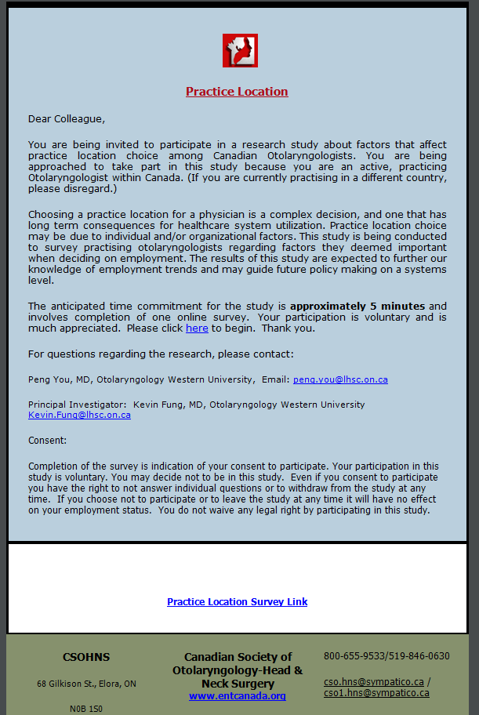

*Email:*

The email will contain the following email script:

“Dear Colleague,

You are being invited to participate in a research study to understand how to increase the adoption of totally endoscopic ear surgery. We would like to invite you to participate in this voluntary, anonymous online survey, because you are a practicing Otolaryngologist. This voluntary survey’s objective is to collect data to answer these research questions by surveying practicing otologists, and to publish the results in a research journal to fill this knowledge gap.

The approximate time to complete the survey is 5 minutes. Your participation or nonparticipation in this survey will be unknown and will not affect your professional status and/or integrity in any way. The survey is to aid in the research of understanding the current experience of endoscopic ear surgery and why it is not widely adopted. This study will be conducted using the two-round Delphi method. The responses of this survey will be collated to develop a second round of more specific questions, which will be sent out in another survey.

For questions regarding the research, please contact:

Arushri Swarup, MASc. Candidate, Institute for Biomaterials and Biomedical Engineering, University of Toronto, email: arushri.swarup@sickkids.ca

Principal Investigator: Dr. Adrian James, Paediatric Otorhinolaryngologist, SickKids Hospital, adrian.james@sickkids.ca

Consent:

By completing and submitting the survey, it will be implied that you consent to participating in the study. Your participation in this study is voluntary, anonymous and confidential. You may decide not to be in this study. Even if you consent to participate you have the right to not answer individual questions or to withdraw from the study at any time.

The survey is available by clicking on the link below:

<Link to survey>”

Landing Page of Survey:

“There is growing interest amongst otologists worldwide around the use of endoscopes in ear surgery. As most ear surgery instruments were developed for use with the microscope, it is possible that changes in instrument design for use with endoscopes may allow more procedures to be completed effectively with a totally endoscopic approach. This project is a not for profit initiative to stimulate the development of instrumentation optimized for endoscopic ear surgery. This survey aims to investigate the suitability of currently available instruments for use in endoscopic ear surgery and identify priorities for improvements in instrument design.

The approximate time to complete the survey is **5 minutes**. The survey will be conducted via a two-round Delphi method. The responses of this survey will be collated to develop a second round of more specific questions, which will be sent out in another survey. The results will then be analyzed and presented in a paper in an otology research journal.

By completing and submitting the survey, it will be implied that you consent to the researchers analyzing and presenting it. You may decide not to be in this study, and may withdraw at any time before submitting the survey.

This survey is completely **voluntary** and will remain confidential and **anonymous** to the researchers. This survey is purely for research purposes.

We thank you for your time. Please continue to begin.”

*Questionnaire:* Please refer to the questionnaire (Appendix C).

In the case that we do not receive any responses within two weeks, we will send out one follow-up email to the invited participants. The email will read:

“Dear Dr.__________,

This is a friendly follow up email to the request to participate in the voluntary survey, linked below, to gather information about why totally endoscopic ear surgery is not widely adopted and practiced. This will aid in a research study aiming to understand the answers to these questions.

It is important to note that this survey is completely voluntary and will remain confidential and anonymous to the researchers. There will be no way to identify the participant to their answers to the survey. As well, participation or nonparticipation in this survey will not affect your professional integrity in any way. This survey is purely for research purposes.

By answering the questions in the survey and submitting it, it will be implied that you consent to filling out your survey and the researchers using the anonymous data to analyze and present it.

We thank you for your time. Please click below to begin.”

<Link to survey>